Biography

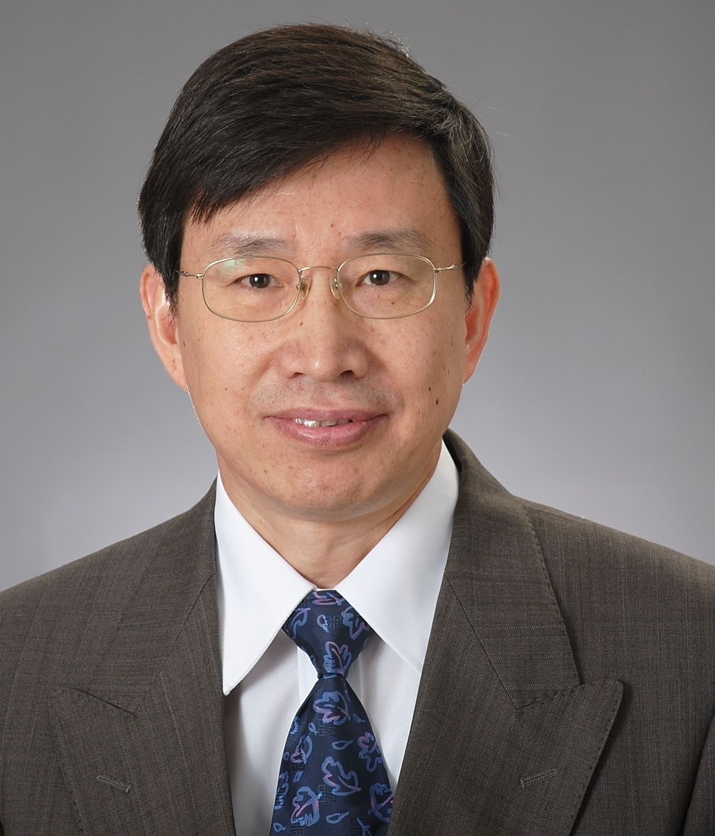
Xiangdang Xue (M’10–SM’12) obtained his B.Eng. degree from Hefei University of Technology, Hefei, Anhui, China, in 1984, his M.Eng. degree from Tianjin University, Tianjin, China, in 1987, and his Ph.D. degree from the Hong Kong Polytechnic University, Hong Kong, China, in 2004, all in electrical engineering.
Dr. Xue engaged in teaching and research in Department of Electrical Engineering, Tianjin University, China, from 1987 to 2001, as a lecturer and an associate professor. He is currently with Department of Electrical Engineering, the Hong Kong Polytechnic University, as a research fellow.
Dr. Xue’s research interests are in the areas of electrical machines, electrical drives, power electronics, and energy storage systems. He has published over 100 papers. His current research is focused on antilock braking systems, electric vehicles, energy storage components, battery management systems, switched reluctance motor drives, and high frequency AC.

 

